**MACHINE LEARNING FILE**

**NAME: SHRUTI GUPTA**

**CLASS: CSE-3**

**ROLL NO.-41476802717**

**EXPERIMENT- 3**

**Problem Statement**

Estimate the accuracy of decision classifier on breast cancer dataset using 5 fold cross validation.

**Github Link**

<https://github.com/Shrutiiig/ML-Assignmnets-Gtbit/tree/master/Decision%20Tree%20with%20Accuracy%20check>

**Program Code Snippet**

**Loading Dataset**

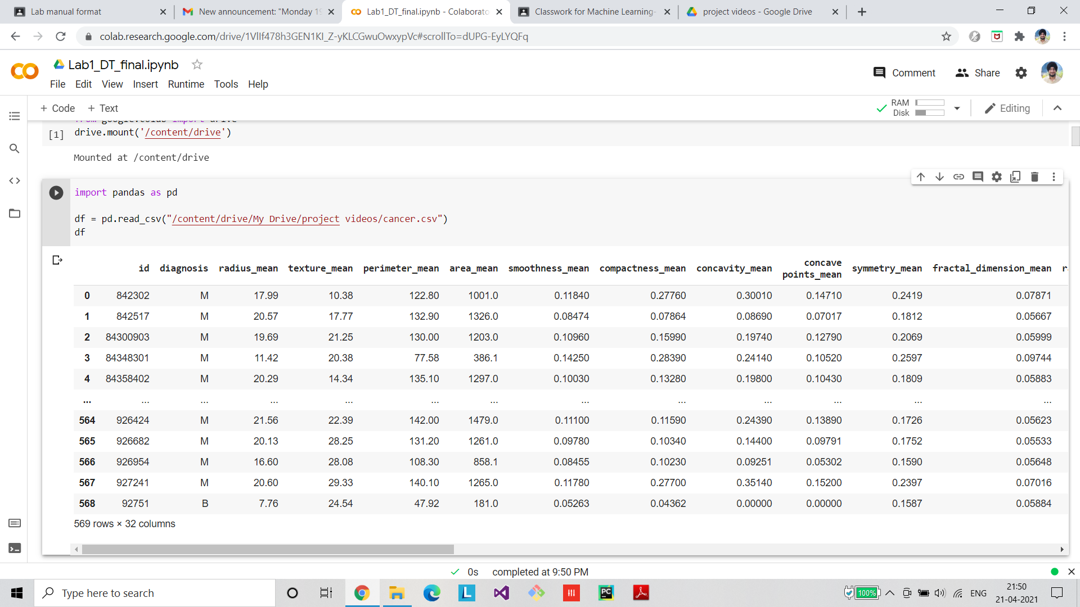

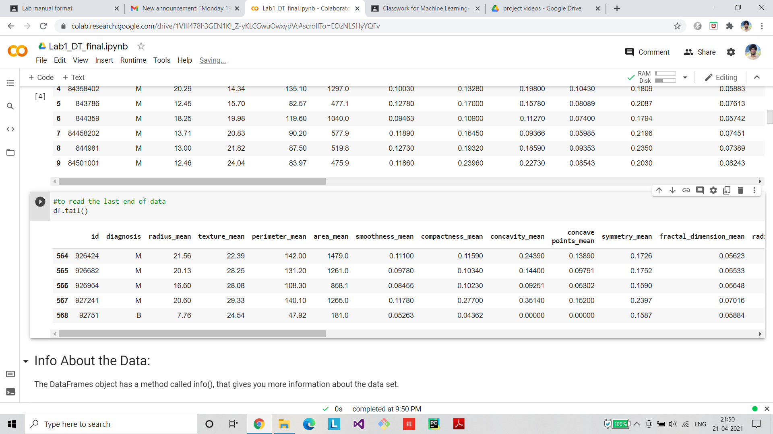

**Preprocessing/Cleaning of dataset**

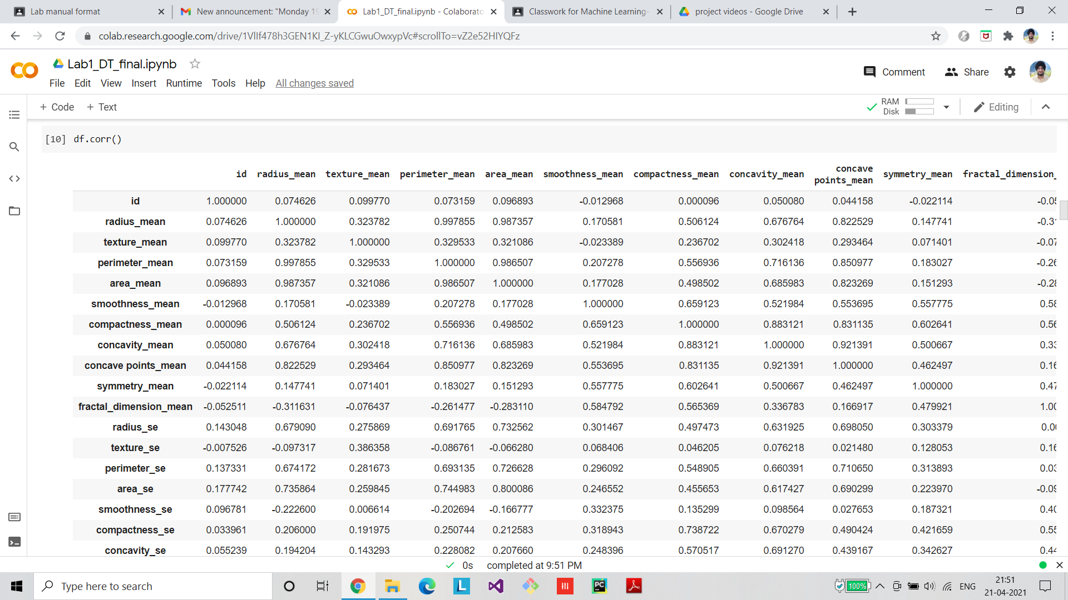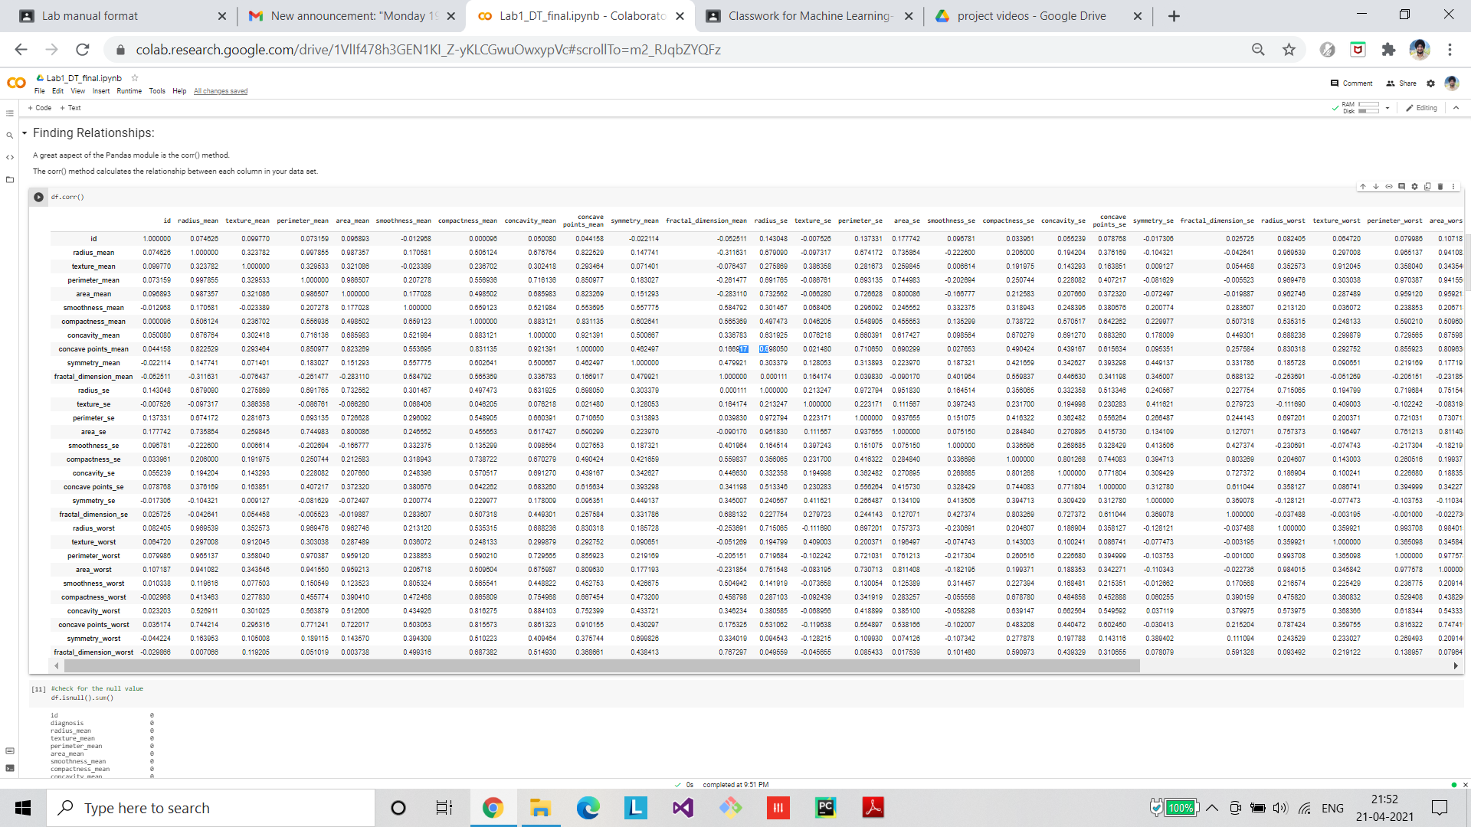

**Visualization**

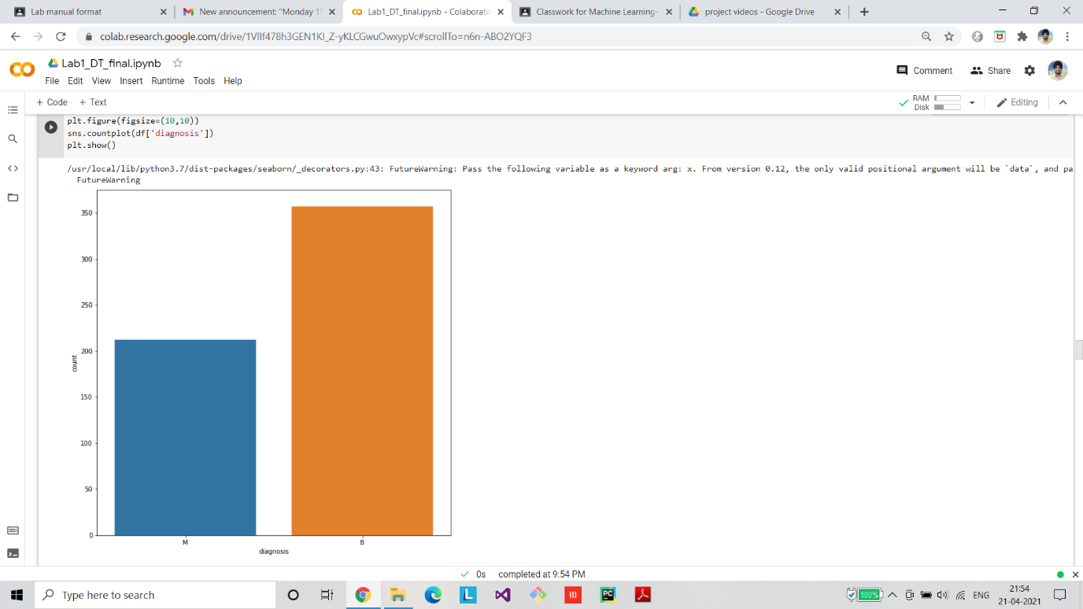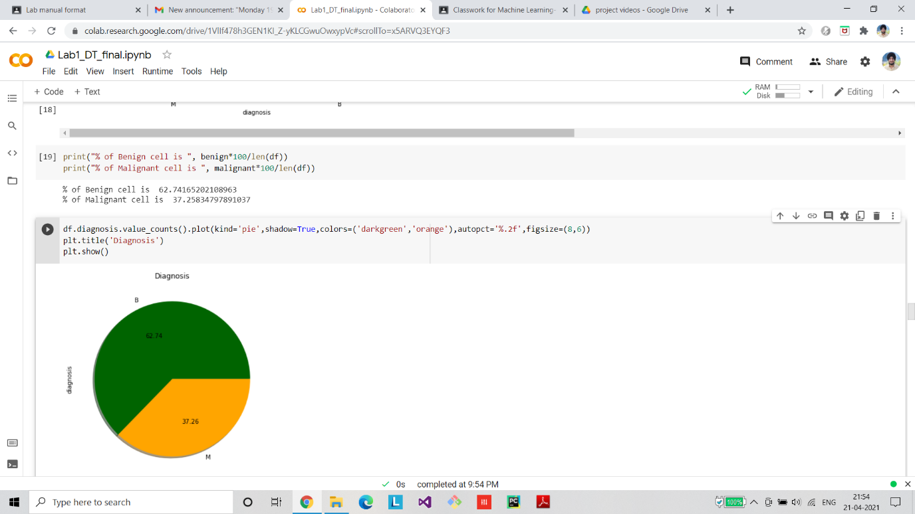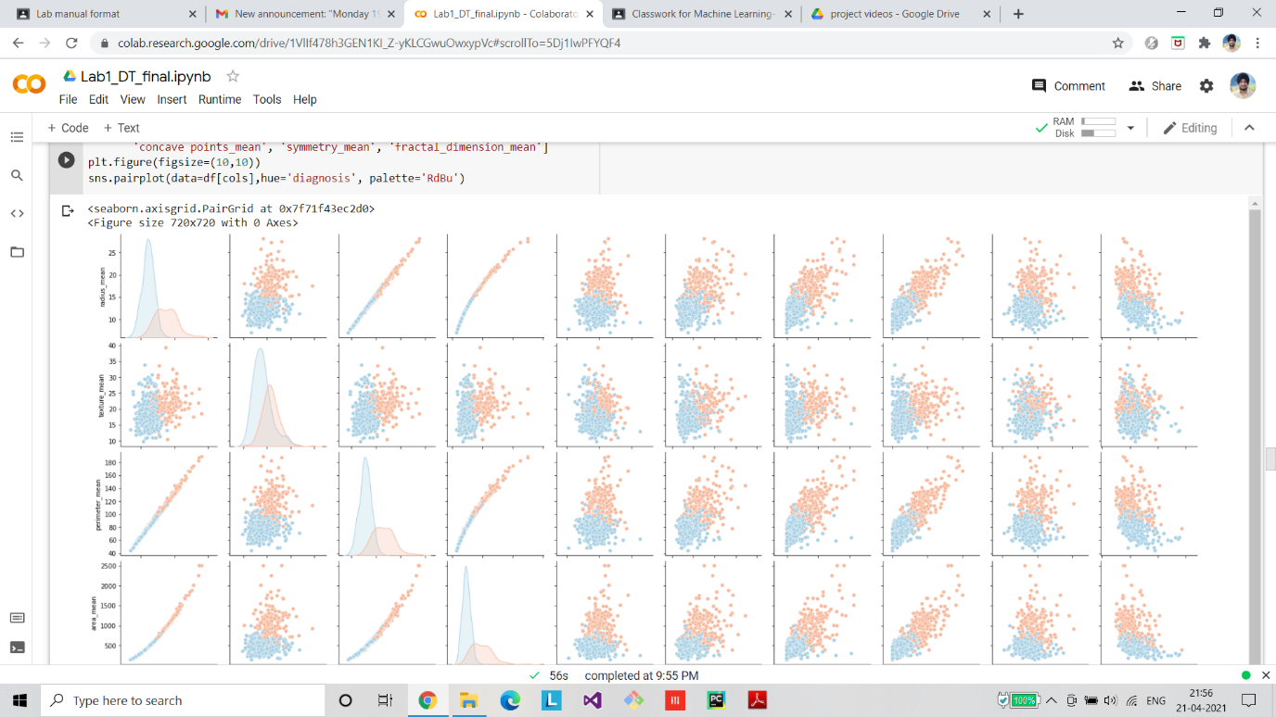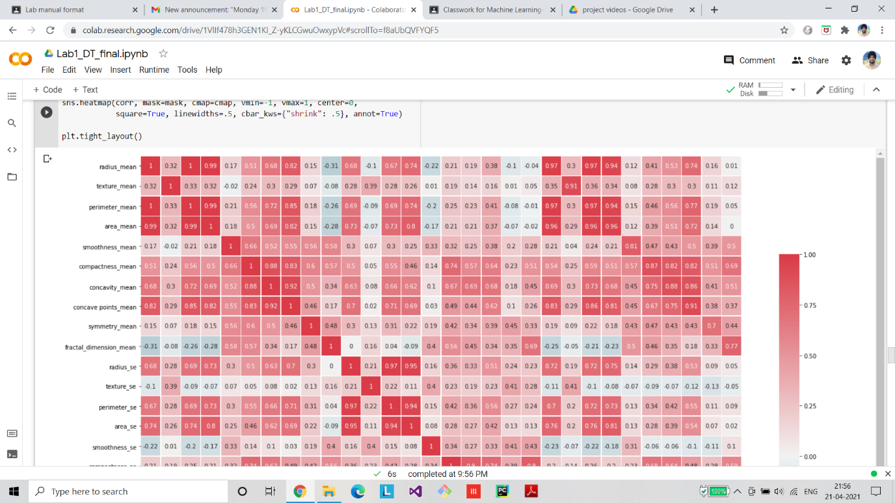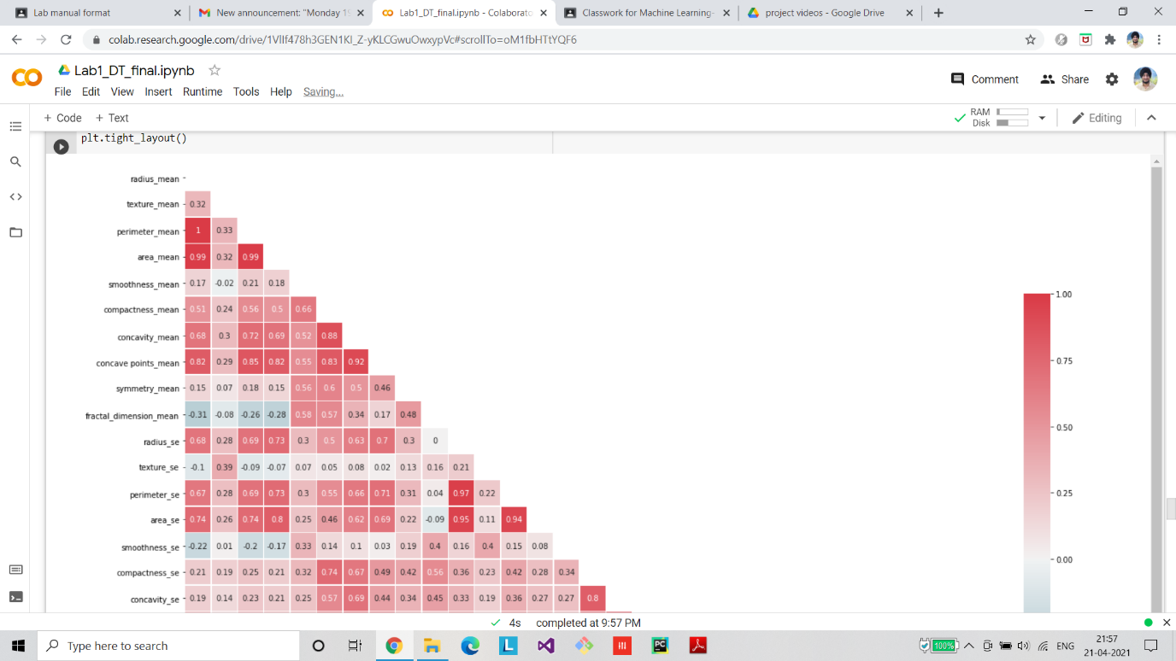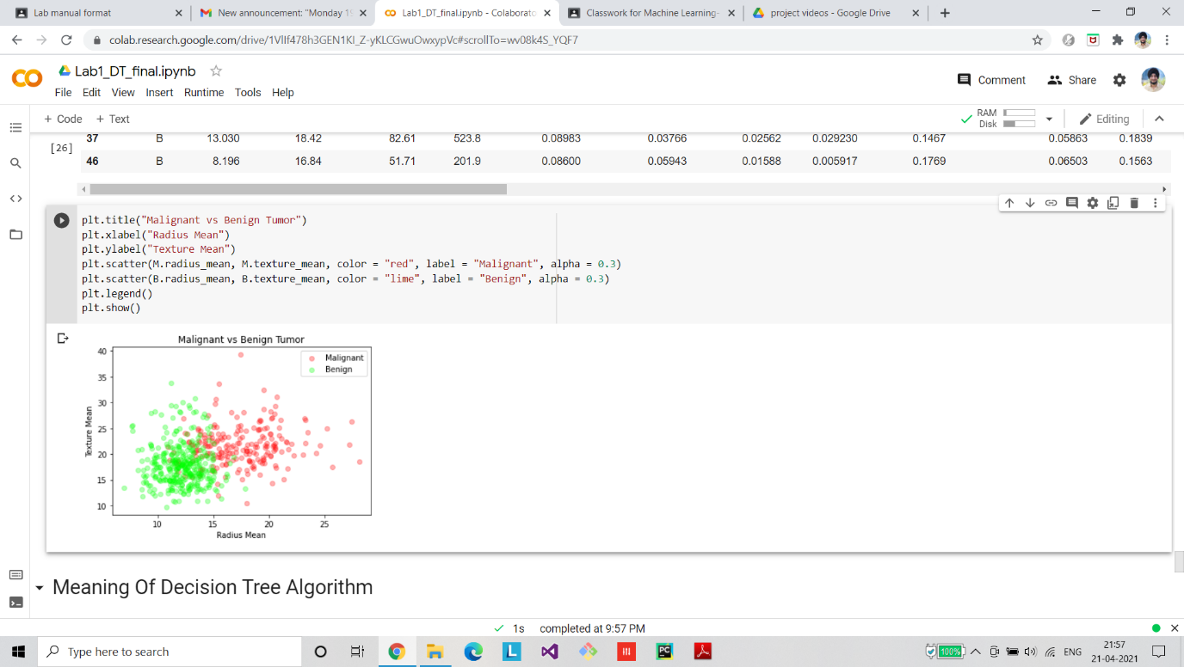

**Algorithm Implementation**

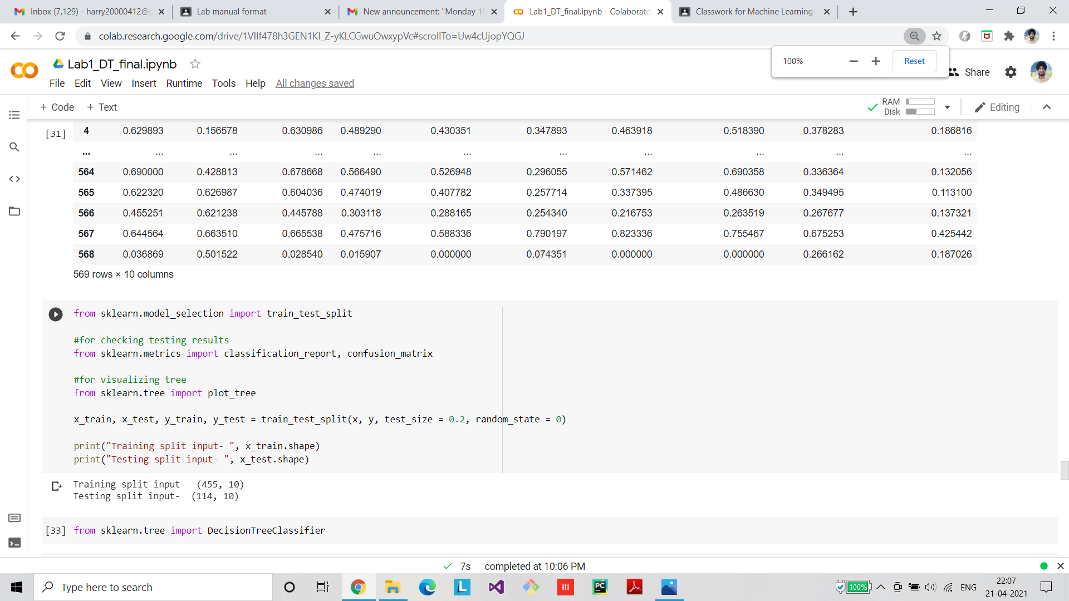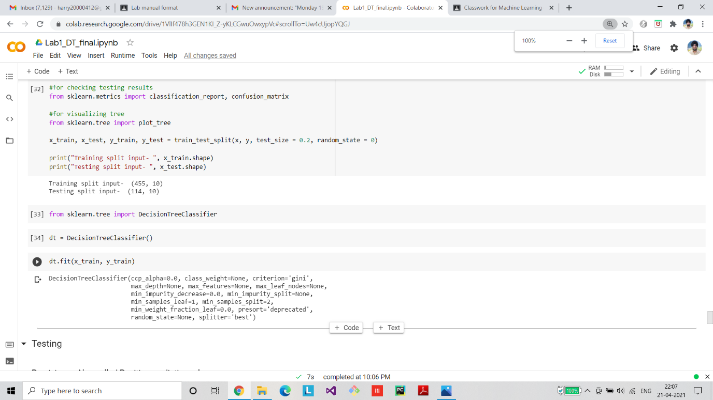

**Final Graph/ROC/Confusion Matrix**

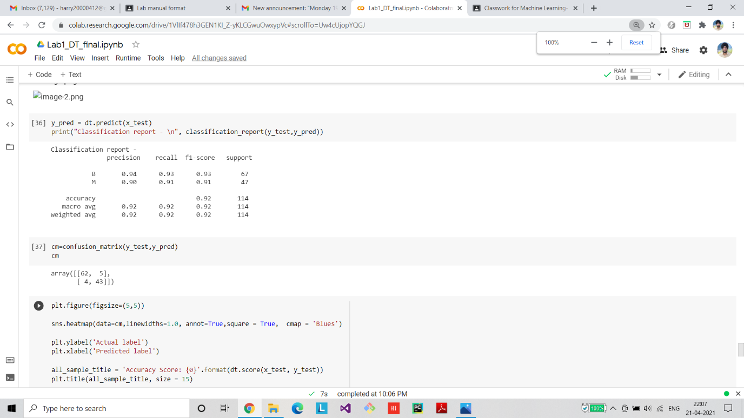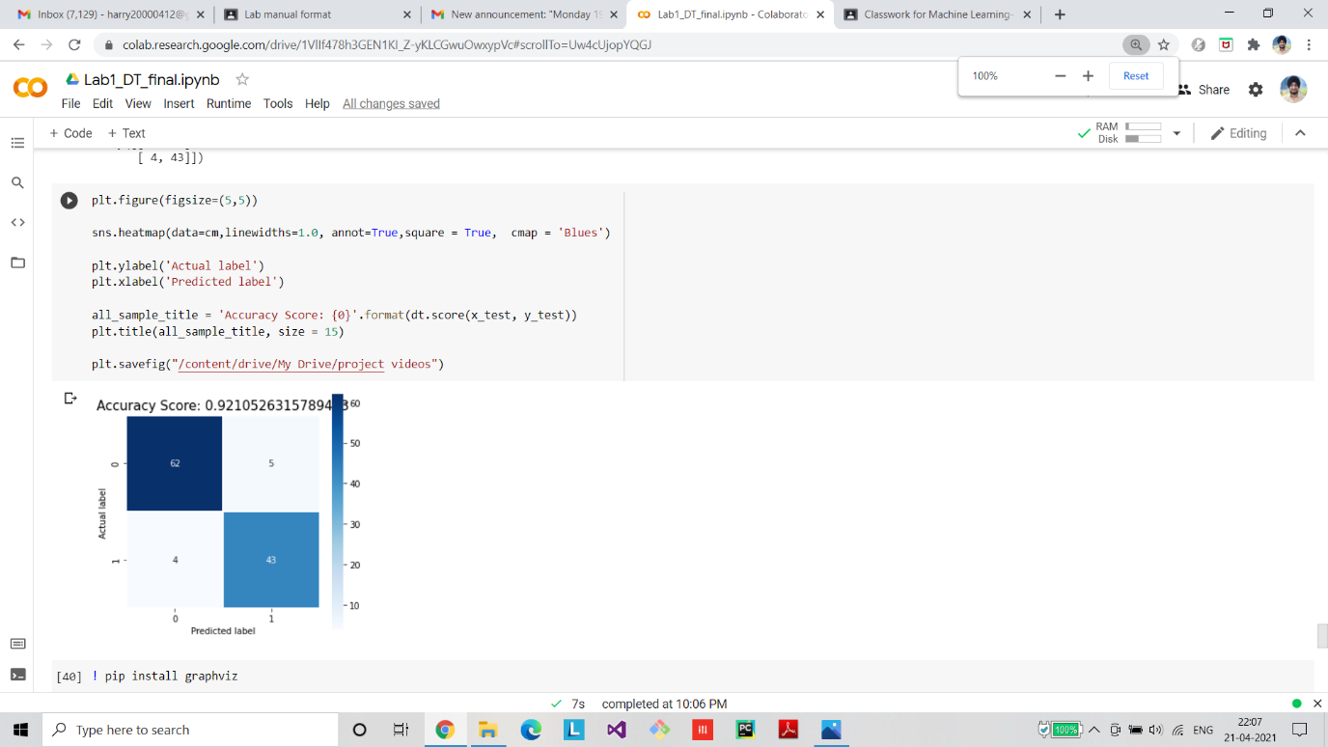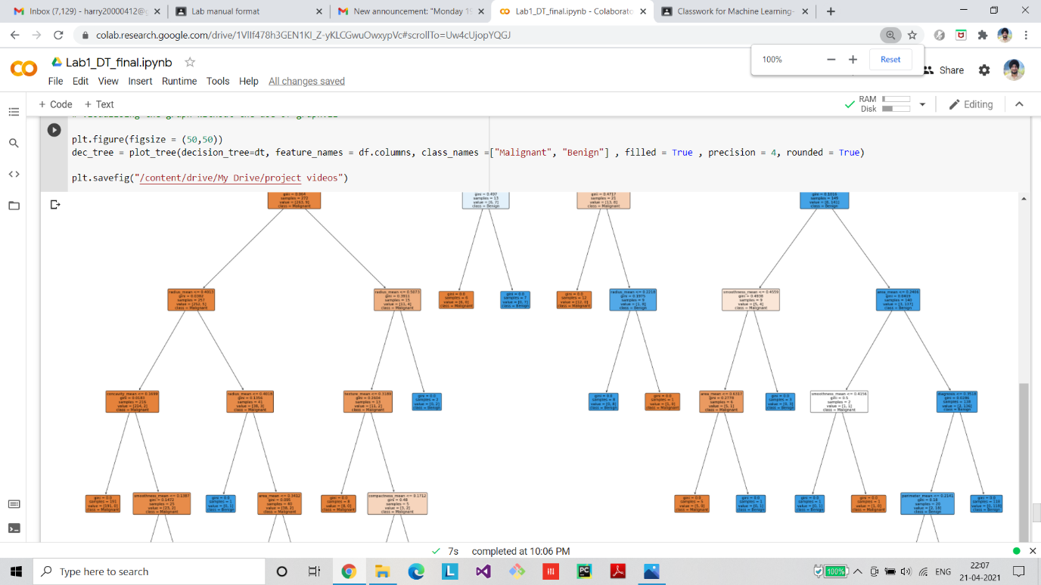

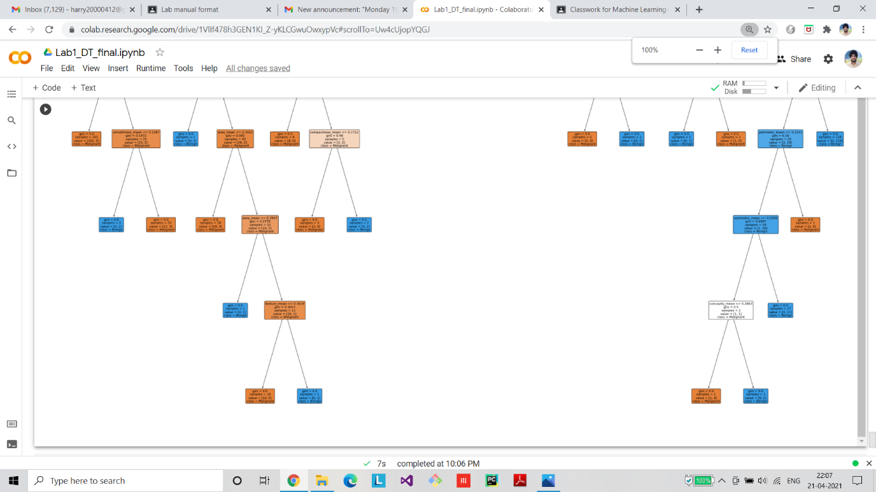

**Applying Fold Cross Validation:**

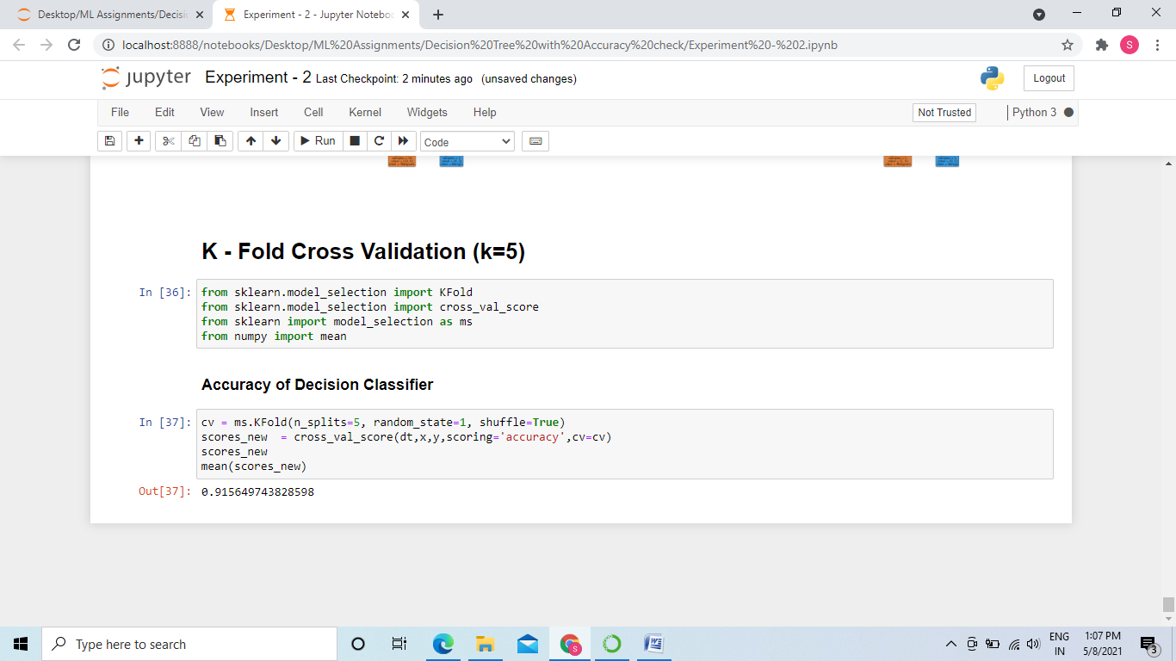

**Github Link**

<https://github.com/Shrutiiig/ML-Assignmnets-Gtbit/tree/master/Decision%20Tree%20with%20Accuracy%20check>